Paper Title

First Author’s Name*
*Department name of the first organization, Name of the first organization, City,Country.
E-mail: E-mail address of the first author
Second Author’s Name♦
♦Department name of the second organization, Name of the first organization, City,Country.
E-mail: E-mail address of the second author
Third Author’s Name▼
▼Department name of the third organization, Name of the first organization, City,Country.
E-mail: E-mail address of the third author
Fourth Author’s Name▲
▲Department name of the fourth organization, Name of the first organization, City,Country.
E-mail: E-mail address of the fourth author
Fifth Author’s Name○
○Department name of the fifth organization, Name of the first organization, City,Country.
E-mail: E-mail address of the fifth author

Abstract
Abstracts should be 300-500 words properly formatted or no more than one page. This document contains information on the preparation of the final version of an abstract accepted for publication in the International Journal of Alive Engineering Education. Please carefully follow the instructions provided to ensure legibility and uniformity of accepted abstracts.

Keywords: About five keywords of phrases in alphabetical order, separated by commas.
1. Introduction
The purpose of this document is to provide information to help authors to produce professional-looking papers for the International Journal of Alive Engineering Education.
2. General Instructions
When writing your article, please follow the instructions:
2.1. Paper Size
The paper will be printed on A4 paper size (210 mm x 297 mm), just as you submit. Thus, the organization and care are of utmost importance. Please make a careful review of the grammatical and typographical errors before submission. There is no page limit and we rely on the good sense of the authors in this case.
Articles should be prepared in plain text. Set the top and bottom margins in 4.94 cm and the left and right margins in 3.48 cm. Use single spacing between the lines.
2.2. Abstract
Abstracts should be 300-500 words properly formatted.
2.3. Sections and subsections
The sections should be numbered with Arabic numbers from 1 (one) and have the title align left. The subsections should follow the progressive numbering from the primary section and must also be aligned to the left and in italics.
2.4. Figures and tables
Figures and tables should be included as part of the text whenever possible. Please avoid placing them before its first mention in the text. It is desirable that the figures have colorful elements and their titles should be positioned after the same, with justified alignment. For tables, the procedure is different: their titles should be placed before the same and centralized. Figure 1 and Graphic 1 are a practical examples.

Figure 1. The label of the figure should be placed here.
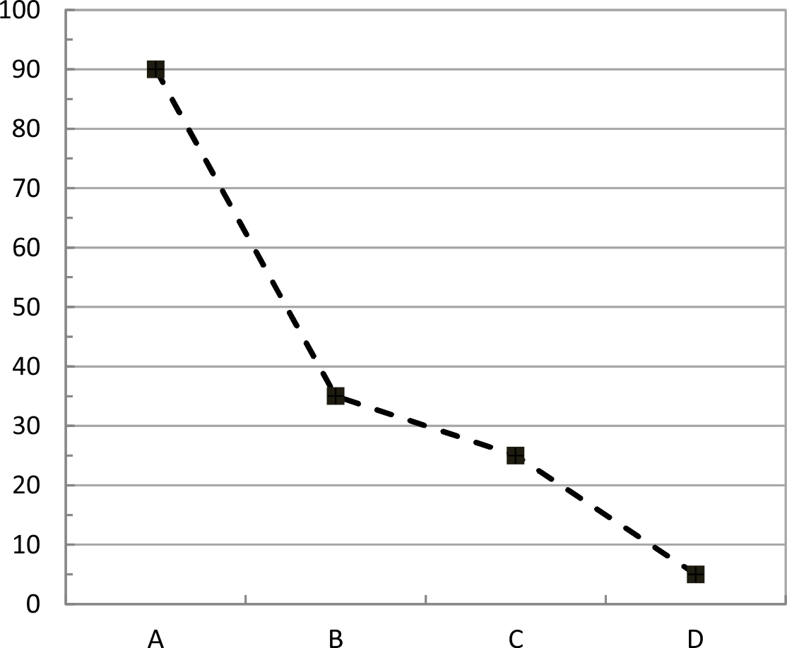
Graphic 1. The label of the graphic should be placed here.
2.5. Fonts
Use font type Computer Modern Roman or Times New Roman. Authors are encouraged to use the Microsoft Word or similar text editor.
2.6. Equations and tables
Equations should be centered and their numbers should be aligned to the right and in parentheses as in Equation 1. Please make sure that the symbols in your equation have been defined before the equation appears or immediately after:

$$∆I_{L = }I_{0}+ \frac{\sqrt{3}}{2} . \frac{V_{i}}{Z}, (1)$$

where $∆I_{L}$ is the peak value of the resonant current, $I_{0}$ is the load current, $V_{i}$is the input voltage, and Z is the characteristic impedance of the resonant circuit.
Table 1 shows the sizes and fonts types.

Table 1. Sizes and fonts types.
Text | Size | Style
Title | 24 pt | Bold
Author's Name | 9 pt | Normal
Affiliation | 9.5 pt | Normal
Main Text | 9.5 pt | Normal
Title of the Sections | 14 pt | Bold
Titles of the Subsections | 12 pt | Bold
Title of the Abstract | 9.5 pt | Bold
Abstract | 9.5 pt | Normal
Figure’s Label | 9 pt | Normal
Table’s Label | 9 pt | Normal
Graphic’s Label | 9 pt | Normal
Frame’s Label | 9 pt | Normal
References | 8.5 pt | Normal
2.7. References
List the references in numerical order at the end of the article. Examples of how to list references depending on the type are listed at the end of this document. Denote the citations within the text by brackets, such as¹.
If you want to make an author’s quote in writing, you can write something like this: according to Meneu, Arcila and Mora (2017): “Many engineering students are usually introduced to the formal presentation of mathematics through a course in linear algebra” ¹.
Other references in the order that appear in the text, such as: ^{2, 3-7, 8, 9}.
2.8. Other questions, photographs and frames
Do not use footnotes unless strictly necessary and in this case, try not to group them. Please make sure you have included address, affiliation and the e-mail of the authors as a footnote on the first page, as shown in this example. Photograph 1 and Frame 1 are a practical examples.

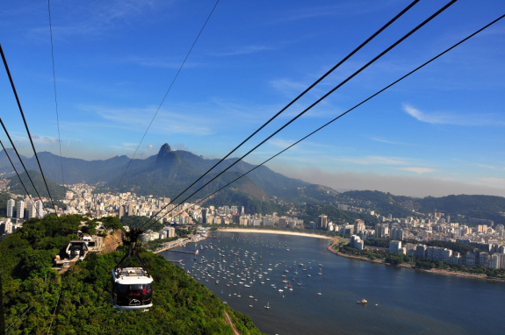
Photograph 1. The label of the photograph should be placed here.

3. Conclusions
The conclusions section is not mandatory. Although this may review the main points of the article. Please do not repeat the abstract as conclusion.
The conclusion should discuss the importance of the work or suggest applications and extensions. Clearly indicates the advantages, limitations and possible applications of the work.

Frame 1. The label of the frame should be placed here.
Part 1: Begin (2015) | Station | Local (Service)
Question 1 | A | South (Help desk)
Question 2 | B | North (Help desk)
Question 3 | C | North (Help desk)
Question 4 | D | South (Help desk)
Question 5 | E | North (Help desk)
Part 2: End (2017) | Station | Local (Service)
Question 6 | F | South (Internet phone service)
Question 7 | G | North (Internet phone service)
Question 8 | H | North (Internet phone service)
Question 9 | I | North (Internet phone service)
Question 10 | J | North (Internet phone service)
Acknowledgment
The purpose of this document is to provide information to help authors to produce professional-looking papers for the International Journal of Alive Engineering Education.
References
1. MENEU, M. J. B.; ARCILA, M. M.; MORA, E. J. Teaching Proposal for The Study of Eigenvectors and Eigenvalues. Journal of Technology and Science Education, Terrassa, v. 7, n. 1, p. 100-113, 2017. Available in: <http://www.jotse.org/index.php/jotse /article/view/ 260>. Accessed on: 14 aug. 2017.
2. TAVARES, S. R. T.; CAMPOS, L. C.; CAMPOS, B. C. O. Análise das abordagens PBL e PLE na Educação em Engenharia com base na Taxonomia de Bloom e no Ciclo de Aprendizagem de Kolb. Revista Eletrônica Engenharia Viva, Goiânia, v. 1, n. 1, p. 37-46, 2014. Available in: <https://www.revistas.ufg.br/revviva/article/view/29254>. Accessed on: 14 aug. 2017.
3. MENGES, Z. A Prática Educativa: Como Ensinar. Porto Alegre: Artmed, 1998.
4. SAVIN-BADEN, M. Problem-based Learning in Higher Education: Untold Stories. Buckingham: Open University Press, 1998.
5. OLIVEIRA, V.; PINTO, D. Reflexões Sobre a Prática do Engenheiro-Professor. In: CONGRESSO BRASILEIRO DE ENSINO DE ENGENHARIA, 40., 2012, Belém. Proceedings... Juiz de Fora: UFJF, 2012. Available in: <http://198.136.59.239/~abengeorg/CobengeAnteriores/2012/artigos /103805.pdf>. Accessed on: 14 aug. 2017.
6. CASALE, A. Aprendizagem Baseada em Problemas: Desenvolvimento de Competências para O Ensino em Engenharia. 2013. 162 p. (Ph.D. Dissertation in Production Engineering)-Universidade de São Paulo, São Paulo, 2013.
7. RIBEIRO, L . R. de C. A Aprendizagem Baseada em Problemas (PBL): Uma Implementação na Educação em Engenharia na Voz dos Atores. 2005. 250 p. (Ph.D. Dissertation in Education)-Universidade Federal de São Carlos, São Carlos, 2005.
8. WEN, B. Transform Learning Based Image and Video Processing. 2015. 100 p. (M.Sc. Dissertation in Electrical and Computer Engineering)-University of Illinois, Urbana, 2015.
9. VERDELL, A. C.; KEITH, J. M.; WARNOCK, J.; WHITE, V. M. Best Practices for Underrepresented Minority Students in An Engineering Summer Bridge Program. In: ASEE ANNUAL CONFERENCE AND EXPOSITION, 123., 2016, New Orleans. Electronic Proceedings.... Mississippi: MSU, 2016. Available in: <https://www.asee.org/public/conferences/64/papers /17173/view>. Accessed on: 14 aug. 2017.

